SPM

Assignment # 5

Solutions

Screenshot 1:

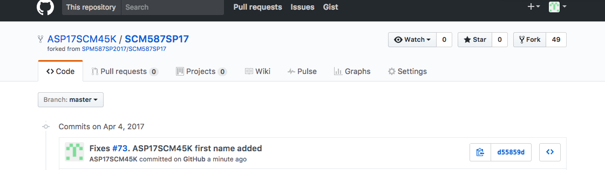

Screenshot 2:

